***Section* 2.3 – Trigonometric Substitutions**

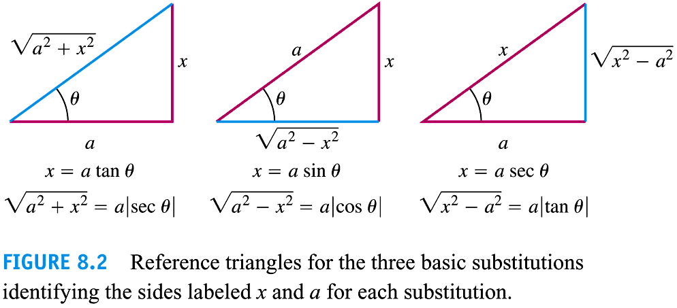







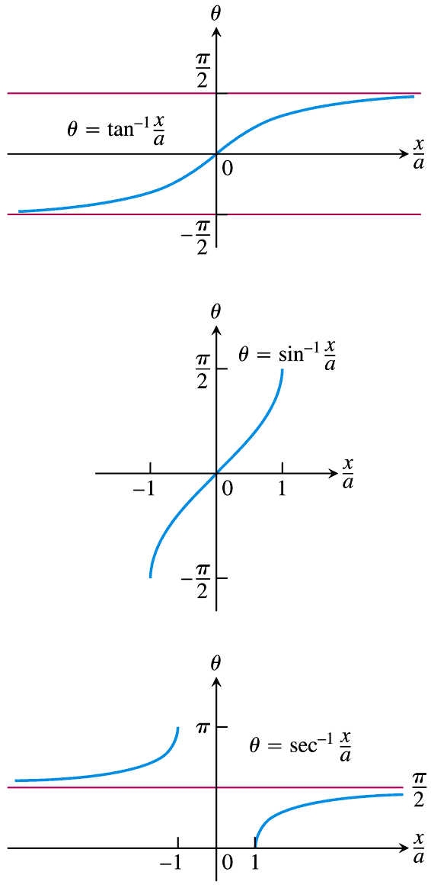



**Procedure for a Trigonometric Substitution**

1. Write down the substitution for *x*, calculate the differential *dx*, and specify the selected values of *θ* for the substitution.
2. Substitute the trigonometric expression and the calculated differential into the integrand, and then simplify the results algebraically.
3. Integrate the trigonometric integral, keeping in mind the restrictions on the angle *θ* for reversibility.
4. Draw an appropriate reference triangle to reserve the substitution in the integration result and convert it back to the original variable *x*.

***Example***

Evaluate 

***Solution***

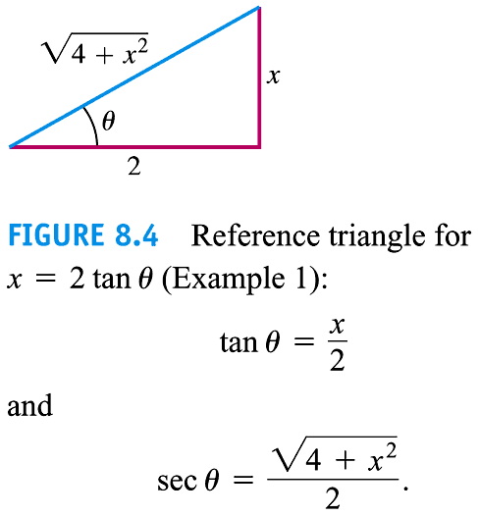Let: 

















***Example***

Evaluate 

**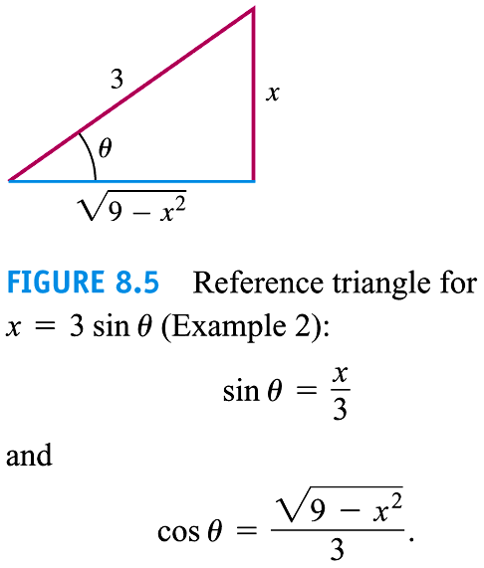*Solution***















 

 





***Example***

Evaluate 

**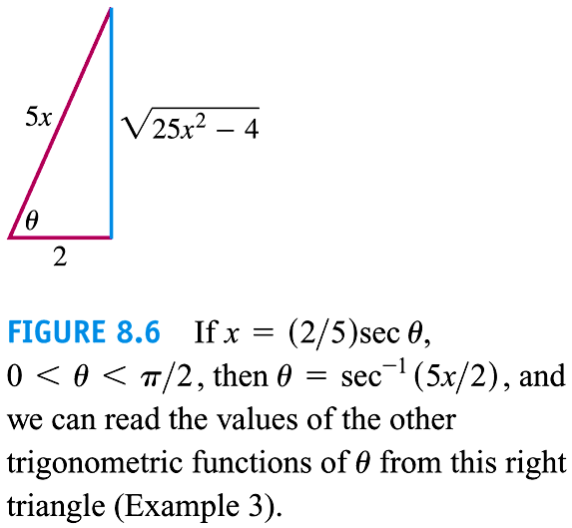*Solution***























***Exercises*** ***Section* 2.3 – Trigonometric Substitutions**

(**1 − 100**) Evaluate the integrals

|  |  |  |
| --- | --- | --- |
|  |  |  |

|  |  |  |
| --- | --- | --- |
|  |  |  |
|  |  |  |

1. Consider the region bounded by the graph  and *y* = 0 for . Find the volume of the solid formed by revolving this region about the *x*-axis.

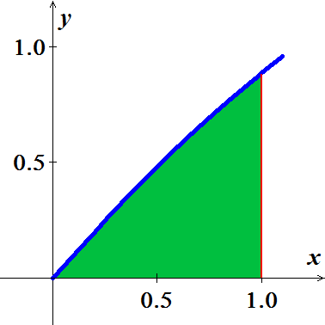

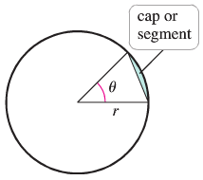

1. Use two approach to show that the area of a cap (or segment) of a circle of radius *r* subtended by an angle *θ* is given by



1. Find the area using geometry (no calculus).
2. Find the area using calculus
3. A lune is a crescent-shaped region bounded by the arcs of two circles. Let  be a circle of radius 4 centered at the origin. Let  be a circle of radius 3 centered at the point . Find the area of the lune that lies inside  and outside .

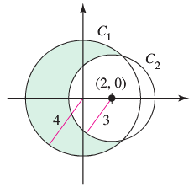

1. The crescent-shaped region bounded by two circles forms a lune. Find the area of the lune given that the radius of the smaller circle is 3 and the radius of the larger circle is 5.

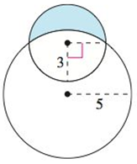

1. Consider the function  and the region ***R*** on the interval [0, 4].
2. Find the area of *R*.
3. Find the volume of the solid generated when *R* is revolved about the .
4. Find the volume of the solid generated when *R* is revolved about the .

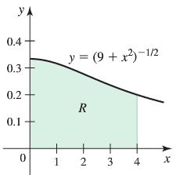

1. A total of ***Q*** is distributed uniformly on a line segment of length 2*L* along the . The *x-*component of the electric field at a point  is given by



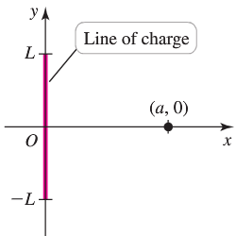

Where *k* is a physical constant and 

1. Confirm that 
2. Letting  be the charge density on the line segment, show that if 
3. A long, straight wire of length 2*L* on the *y-axis* carries a current *I*. according to the Biot-Savart Law, the magnitude of the field due to the current at a point  is given by



Where  is a physical constant, , and *θ*, *r*, and *y* are related to the figure

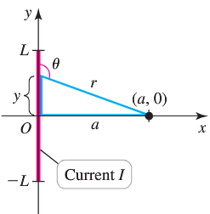

1. Show that the magnitude of the magnetic field at  is 
2. What is the magnitude of the magnetic field at  due to an infinitely long wire ?
3. The cycloid is the curve traced by a point on the rim of a rolling wheel. Imagine a wire shaped like an inverted cycloid.

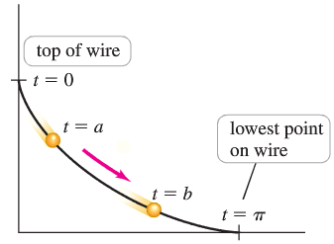

A bead sliding down this wire without friction has some remarkable properties. Among all wire shapes, the cycloid is the shape that produces the fastest descent time. It can be shown that the descent time between any two points  on the curve is



Where *g* is the acceleration due to gravity,  corresponds to the top of the wire, and  corresponds to the lowest point on the wire.

1. Find the descent time on the interval .
2. Show that when , the descent time is the same for all values of *a*; that is, the descent time to the bottom of the wire is the same for all starting points.
3. Find the area of the region bounded by the curve and the  on the interval 
4. Find the length of the curve from  to , where  is a real number.
5. Find the arc length of the graph of  from  to 
6. A projectile is launched from the ground with an initial speed *V* at an angle  from the horizontal. Assume that the  is the horizontal ground and *y* is the height above the ground. Neglecting air resistance and letting *g* be the acceleration due to gravity, it can be shown that the trajectory of the projectile is given by



1. Note that the high point of the trajectory occurs at . If the projectile is on the ground at  and , what is *a*?
2. Show that the length of the trajectory (arc length) is 
3. Evaluate the arc length integral and express your result in the terms of *V, g*, and .
4. For fixed value of *V* and *g*, show that the launch angle  that maximizes the length of the trajectory satisfies 
5. Let . The figure shows that



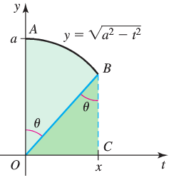

1. Use the figure to prove that 
2. Conclude that 
3. A sealed barrel of oil (weighing 48 pounds per cubic foot) is floating in seawater (weighing 64 pounds per cubic foot). The barrel is not completely full of oil. With the barrel lying on its side, the top 0.2 *foot* of the barrel is empty.

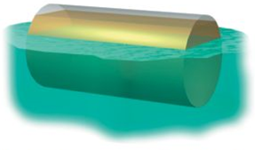 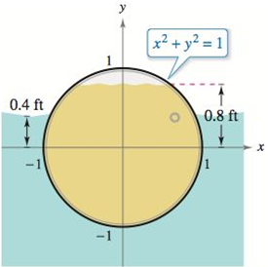

Compare the fluid forces against one end of the barrel from the inside and from the outside.

1. The axis of a storage tank in the form of a right circular cylinder is horizontal. The radius and length of the tank are 1 *meter* and 3 *meters*, respectively.

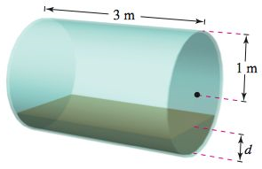

1. Determine the volume of fluid in the tank as a function of its depth *d*.
2. Graph the function in part (*a*).
3. Design a dip stick for the tank with markings of 
4. Fluid is entering the tank at a rate of . Determine the rate of change of the depth of the fluid as a function of its depth *d*.
5. Graph the function in part (*d*).\When will the rate of change of the depth be minimum?
6. The surface of a machine part is the region between the graphs of 

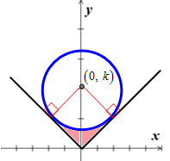

1. Find *k* when the circle is tangent to the graph of 
2. Find the area of the surface of the machine part.
3. Find the area of the surface of the machine part as a function of the radius *r* of the circle.
4. The field strength *H* of a magnet of length 2*L* on a particle *r* units from the center of the magnet is



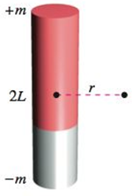

Where  are the poles of the magnet

Find the average field strength as the particle moves from 0 to *R* ***units*** from the center by evaluating the integral

